Updated 1/7/24

Orange - MS/HS Snow & Emergency Route

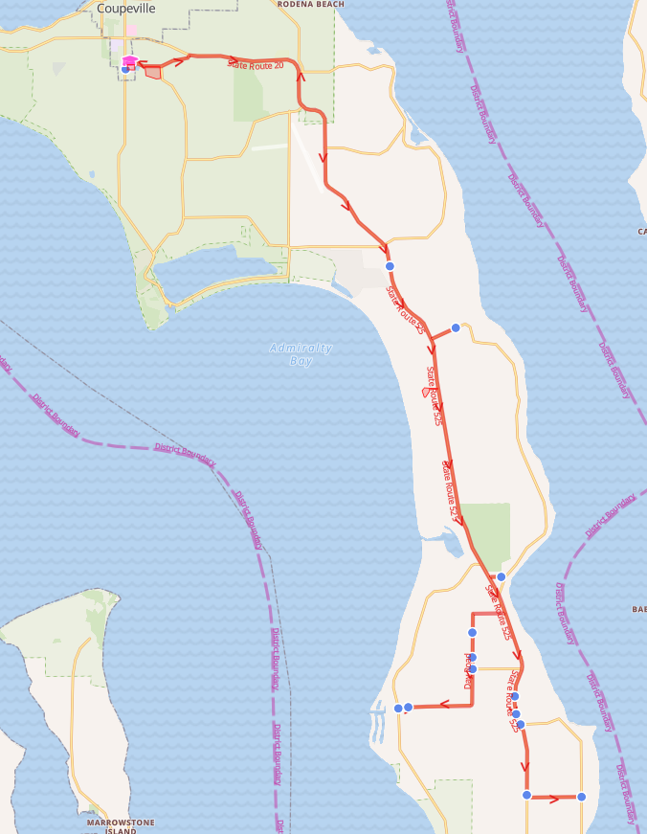

Orange - MS/HS Snow & Emergency Route

Reg Start 2- Hr. Delay
7:06 AM | 9:06 AM | Lagoon Point Rd & Gylany Way
7:07 AM | 9:07 AM | Lagoon Point Rd & Smugglers Cove Rd (Fire House)
7:11 AM | 9:11 AM | Day Rd & Christenson Rd
7:12 AM | 9:12 AM | 3339 Day Rd
7:13 AM | 9:13 AM | 3150 Day Rd
7:17 AM | 9:17 AM | 23947 SR 525
7:18 AM | 9:18 AM | SR 525 & Larson Rd
7:20 AM | 9:20 AM | SR 525 & Classic Rd
7:22 AM | 9:22 AM | Classic Rd & Honeymoon Bay Rd
7:26 AM | 9:26 AM | SR 525 & Resort Rd
7:30 AM | 9:30 AM | Wonn Rd (Greenbank Farm Drive)
7:36 AM | 9:36 AM | Houston Rd & Grateful Acre Pl
7:39 AM | 9:39 AM | 29954 SR 525

Orange - Elementary Snow & Emergency Route

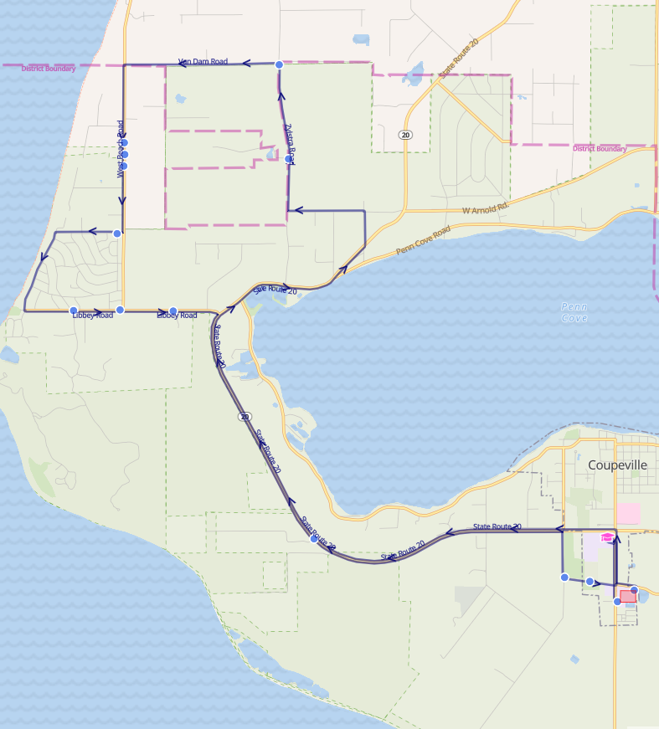

Orange - Elementary Snow & Emergency Route

Reg Start 2- Hr. Delay
8:19 AM | 10:19 AM | Zylstra Rd & Roberts Pond Ln
8:21 AM | 10:21 AM | Zylstra Rd & Van Dam Rd
8:26 AM | 10:26 AM | 1004 West Beach Rd
8:26 AM | 10:26 AM | 994 West Beach Rd
8:27 AM | 10:27 AM | 951 West Beach Rd
8:28 AM | 10:28 AM | La Mesa Dr & El Pozo St
8:32 AM | 10:32 AM | Libbey Rd & Hill Valley Dr
8:34 AM | 10:34 AM | 2504 Libbey Rd
8:35 AM | 10:35 AM | 2384 Libbey Rd
8:38 AM | 10:38 AM | Hwy 20 & Winterhawk Ln
8:41 AM | 10:41 AM | Terry Rd & Ebey Rd
8:42 AM | 10:42 AM | Terry Mobile Home Park

